IIS configuration:

Requirements for WebPortal Password setting:

Windows Backend configuration:

ADUC installed

PHP

IIS

Create AD user and log in to the machine at console.

Recomendations:

Active Directory User delegate (<https://community.spiceworks.com/how_to/1464-how-to-delegate-password-reset-permissions-for-your-it-staff>)

Only provide Administrator credentials for Powershell profile setup on the server. Administration credentials can be removed afterwards.

Powershell execution policy: Recomended Signed (<https://blogs.technet.microsoft.com/heyscriptingguy/2010/06/16/hey-scripting-guy-how-can-i-sign-windows-powershell-scripts-with-an-enterprise-windows-pki-part-1-of-2/>)

IIS config:->Site->Authentication->Anonymous Authentication->Edit (AD user credential)

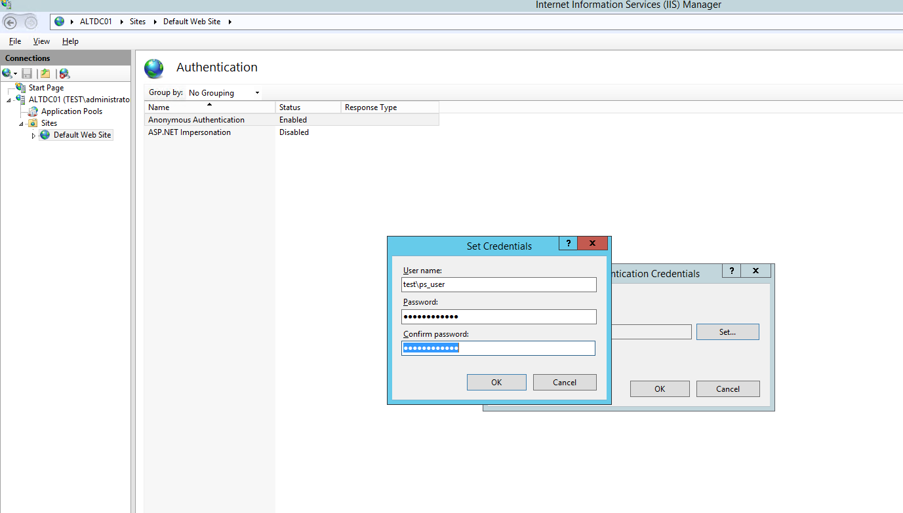

Mysql connector (<http://dev.mysql.com/downloads/connector/net/1.0.html>) (included)

Powershell 5.0 or newer recommended (<https://www.microsoft.com/en-us/download/details.aspx?id=50395>)

Front end Webserver:

If same server as backend:

Mysql install

Todo:

Write powershell installer for 1 server configuration

Write powershell installer for 2 server configuration